PRE-K HOME LEARNING
May 4th-8th 2020
CHOICE BOARD
Choose an activity to do each day. Don’t worry about crossing off the activities after you have finished. You can do these activities multiple times! We will add more activities each week. Just have fun with this! Be sure to look for updates every Monday on our teacher’s website.
Reading | Math | Science | Movement | Creativity
Mothers are special and animals have them too. Hope you enjoy this story: youtube.com/watch?v=gTgq16pnP08  Here’s a great story about a caterpillar that turns into a butterfly.  https://www.youtube.com/watch?v=76SEueaI954  This is a fun song from Jack Hartmann called, What letter is it? https://www.youtube.com/watch?v=qwOQvh_mJ4w  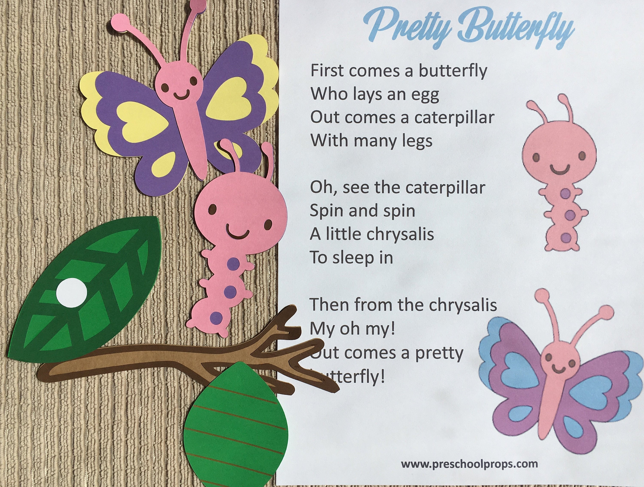  Listen to two stories about butterflies.  Waiting For Wings by Lois Ehlert  and  Butterflies by Martha E. H. Rustad  https://bookflix.digital.scholastic.com/pair/detail/bk0072pr/start?authCtx=U.794217314  Listen to a story. Then pick an activity from the Daily Reading Quests list to discuss with a grown up.  https://classroommagazines.scholastic.com/support/learnathome/grades-prek-k/daily-reading-quest.html | Caterpillar Number Sequencing  Cut out 11 circles the size of your child’s hand out of paper white or any other color.  Place a blank circle on the table/floor as the caterpillar head. Then write numbers 1-10 on the other circles. Have your child place the circles in order from 1-10 to create a caterpillar. They can color the circles and make a face on the first one. Send us pictures of your child’s creations.  Count along with this butterfly story!  https://www.youtube.com/watch?v=kBi_RoXKVo0 | Here is fun Science song about the stages of a butterfly. Click the link below  https://www.youtube.com/watch?v=8rvGUevGxDk  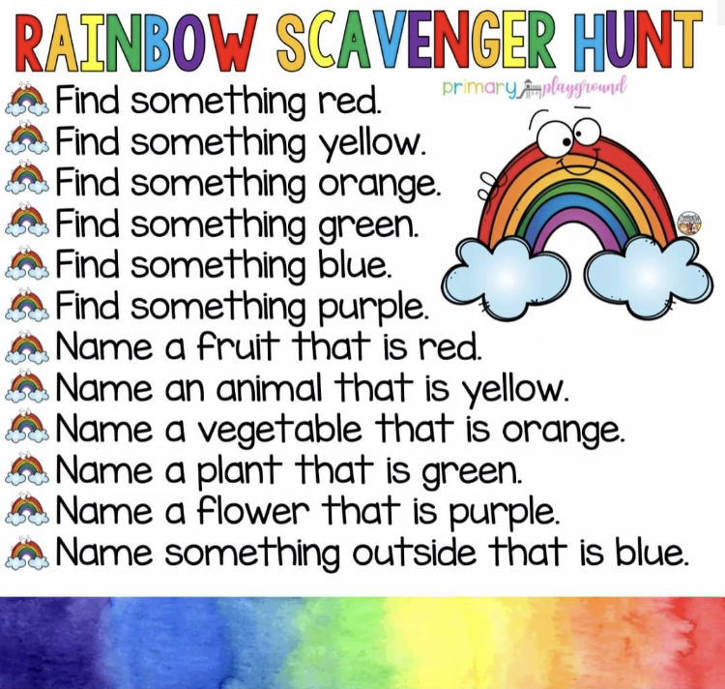  Watch a video of the life cycle of a butterfly.  https://watchandlearn.scholastic.com/videos/animals-and-plants/baby-animals-and-life-cycles/the-life-of-a-butterfly.html | This is a fun movement activity called the butterfly dance.  http://www.youtube.com/watch?v=1EQeYA5Qbic  Here is another way to have fun acting like a caterpillar through the lifecycle stages have fun!  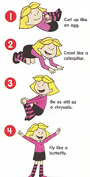  Here’s another way to act out the changes a butterfly goes through during metamorphosis. Ask a parent to read about each stage and act them out.  English:  https://letsfindout.scholastic.com/pages/sandbox/activity-a-butterfly-changes.html  Spanish:  https://letsfindout.scholastic.com/pages/sandbox/esp/semana-3-dia-13.html | Please save the following items for projects in the upcoming weeks: small boxes, cereal boxes, cracker and rice boxes, tissue boxes, lids from water bottles or any other size lids, toilet paper and paper towel rolls, paper plates and buttons.  Butterfly Coffee Filters  You will need coffee filters, markers, spray bottle or dropper, clothes pin or pipe cleaner  ~Color the coffee filter with different colored markers  ~apply water to the coffee filter  ~Let Coffee filter dry  ~Draw a face on the clothes pin  ~Grasp the coffee filter in the middle and attach the clothes pin.  